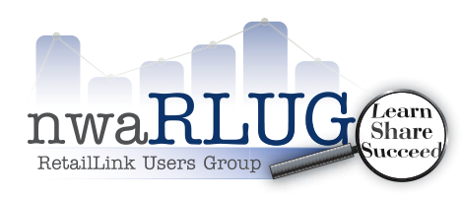
nwaRLUG Monthly Meeting
August 16, 2018 2:00 PM – 4:00 PM
Northwest Arkansas Community College Campus
Shewmaker Center – Walmart Auditorium
1000 SE Eagle Way, Bentonville, AR 72712
Tentative Topic: Pending
Subject to Change

- Current Valid Retail Link ID is required to attend nwaRLUG Meetings
- 2018 nwaRLUG Membership Dues can be paid at www.nwaRLUG.org
(One Membership per Company)
Monthly Agendas can be found at www.nwaRLUG.org

